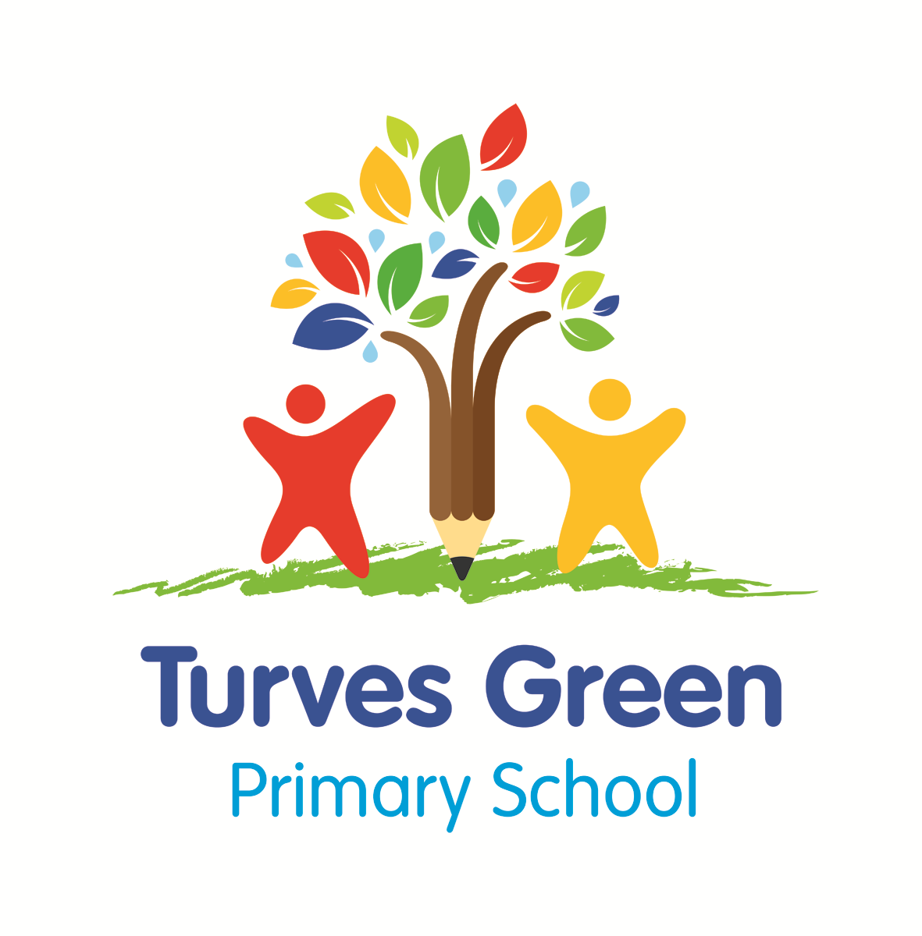
Turves Green Primary School

English as an Additional Language (EAL) Policy

July 2022

Laura Allden

Assistant Head Teacher Inclusion Lead

Links to Rights Respecting:

A2: The convention applies to every child whatever their ethnicity, gender, religion, abilities, whatever they think or say, no matter what type of family they come from.
A29: Education must develop every child’s personality, talents and abilities to the full. It must encourage the child’s respect for human rights, as well as respect for their parents, their own and other cultures, and the environment.
A30: Every child has the right to learn and use the language, customs and religion of their family, whether or not these are shared by the majority of the people in the country where they live

Contents
1. Legislation and guidance 2
2. Our School Values 2
3. Aims 2
4. What is EAL? 2
5. Induction 3
6. Teaching and Learning………………………………………………………………………………………..4
6. Curriculum Access 4
7. Assessment 5
8. Roles and Responsibilities……………………………………………………………………………………….5

…………………………………………………………………………………………………………………………….

1. Legislation and guidance
This policy refers to:
- The Equality Act 2010 (HMSO)
- 2017-2018 school census guide (DfE, 2018)
- The national curriculum in England Key stages 1 and 2 framework document (DfE, 2013)
- Statutory Framework for the Early Years Foundation Stage (DfE, 2017)
- Teachers Standards (DfE, 2013)

2. Our School Values

At Turves Green Primary School the teaching and learning, achievements, attitudes and well-being of all our children are valued. We encourage and support all our children to achieve the highest possible standards. We do this through taking account of each child’s life experiences and needs.
Our values thread through everything we do:
- Be ready
- Be respectful
- Be safe

3. Aims
The National Curriculum secures entitlement for all children to a number of areas of learning and gives them the opportunity to develop the knowledge, understanding, skills and attitudes that are necessary for their self-fulfilment and development as responsible citizens. We promote the principles of fairness and justice for all through the education that we provide at Turves Green Primary School.
The aim of this policy is to help ensure that we meet the full range of needs of those children who are learning English as an additional language. This is in line with the requirements of the Equality Act 2010.

4. What is EAL?
English as an Additional Language (EAL) includes both English as a second language and English as a foreign language – it is for pupils spending a short time in Britain, and for those who have settled here permanently. EAL is the study of English by students who already speak at least one other language or who come from a home in which a language other than English is used. We recognise that EAL status is dependent on which language was learned first by a child and the languages used within the home.
We are proactive in removing barriers that stand in the way of our EAL pupils learning and success. We do this by meeting our responsibilities to our EAL pupils ensuring they have equal access to the curriculum (and other educational opportunities) and the achievement of their educational potential and by providing our EAL pupils with a safe, welcoming, nurturing environment where they are accepted, valued and encouraged to participate. We promote the principles of fairness and justice for all through the education that we provide at Turves Green Primary School ensuring EAL pupils receive opportunities for educational success that equals that of English-speaking pupils.

5. Induction
Turves Green Primary follows the PSS Induction flowchart (Appendix 1).
The school will:
- Arrange a meeting with parents/carers to gather a range of basic information e.g. languages used in the home, previous schooling, and exposure to English. Ask parents/carers to bring in any reports, school text and exercise books from the pupil’s previous school.
- Give a tour of the school, with an interpreter in attendance if possible/ required.
- Share the Parent Induction Pack including information about the school, locality and English school system.
- Update staff who come into regular contact with the child (Teacher, TA, Year group members etc.) with any specific information which may support teaching and learning.
- Establish a buddy system so that child has a ‘go to’ child for support. Also identify a key adult.
- Within the first two weeks the EAL co-ordinator will assess the child using the Initial Speaking and Listening Assessment. The results from this will inform planning, teaching and targeting.
- Once settled classteachers will complete an BELL EAL Assessment Profile.

From 2016-2019, schools needed to assess each EAL pupil’s proficiency level using a five-point scale (see box below). Although no longer statutory, we continue to use this scale to support teaching and learning. All children with EAL have this proficiency code recorded on our Management Information System (Arbor). This enables us to monitor provision and secure funding for children as appropriate.
New to English (Code ‘A’):
May use first language for learning and other purposes. May remain completely silent in the classroom. May be copying/repeating some words or phrases. May understand some everyday expressions in English but may have minimal or no literacy in English. Needs a considerable amount of EAL support.
Early acquisition (Code ‘B’):
May follow day to day social communication in English and participate in learning activities with support. Beginning to use spoken English for social purposes. May understand simple instructions and can follow narrative/accounts with visual support. May have developed some skills in reading and writing. May have become familiar with some subject specific vocabulary. Still needs a significant amount of EAL support to access the curriculum.
Developing competence (Code ‘C’):
May participate in learning activities with increasing independence. Able to express self orally in English, but structural inaccuracies are still apparent. Literacy will require ongoing support, particularly for understanding text and writing. May be able to follow abstract concepts and more complex written English. Requires ongoing EAL support to access the curriculum fully.
Competent (Code ‘D’):
Oral English will be developing well, enabling successful engagement in activities across the curriculum. Can read and understand a wide variety of texts. Written English may lack complexity and contain occasional evidence of errors in structure. Needs some support to access subtle nuances of meaning, to refine English usage, and to develop abstract vocabulary. Needs some/occasional EAL support to access complex curriculum material and tasks.
Fluent (Code ‘E’):
Can operate across the curriculum to a level of competence equivalent to that of a pupil who uses English as his/her first language. Operates without EAL support across the curriculum.

6.Teaching and Learning
At Turves Green Primary School teachers take action to help children who are learning English as an additional language in many ways and follow advice and guidance from Pupil and School Support (PSS) and The Bell Foundation (www.bell-foundation.org.uk).
We develop spoken and written English by:

ensuring that vocabulary work covers the technical as well as the everyday meaning of key words, metaphors and idioms;

explaining how speaking and writing in English are structured for different purposes across a range of subjects;

providing a range of reading materials that highlight the different ways in which English is used;

ensuring that there are effective opportunities for talking, and that talking is used to support writing;
- encouraging children to transfer their knowledge, skills and understanding of one language to another;

building upon children’s experiences of language at home and in the wider community, so that their developing uses of English and other languages support one another (translanguaging)
We ensure access to the curriculum and assessment by:

using accessible texts and materials that suit children's ages and levels of learning;

providing support through ICT, video or audio materials, dictionaries and translators, visual support materials, readers, etc.;

using the home or first language where appropriate;

providing bilingual support to enable children to access the curriculum, learn basic classroom routines and to continue children's language development in their first language;

adult support which allows children to work in smaller groups and increases opportunities for modelling language structures and for conversations between adults and children;

additional support to target groups of children who are operating at a level or more behind that which would be expected for their age/time in school.

7. Curriculum Access
All children at Turves Green Primary School follow the curricular requirements of the Foundation Stage and the National Curriculum. Where possible children receive support from Class teachers and Teaching Assistants within classrooms. However, some withdrawal support for children with EAL may take place. This support is clearly linked to the National Curriculum and reviewed regularly. The support may be used to address a particular language or learning focus.
These may include:
- pre-tutoring;
- post tutoring to reinforce key language and concepts;
- small group interventions i.e. Word Aware 3.
In the Foundation Stage we plan opportunities for children to develop their English and we provide support to help them take part in all activities.
The Foundation Stage helps children learning English as an additional language by:
- building on children's experiences of language at home and in the wider community, so that their developing uses of English and of other languages support one another;
- providing a range of opportunities for children to engage in oracy activities in English with peers and adults;
- providing bilingual support to extend vocabulary;
- providing a variety of writing in the children's home languages as well as in English;
- providing opportunities for children to hear their home languages as well as English.

8. Assessment

At Turves Green Primary School we use the BELL EAL Assessment Profiles on a termly basis (minimum) to assess competency and development. This is alongside the use of the school assessment tracker (Arbor). Proficiency codes are recorded on Arbor annually.

9. Roles and Responsibilities
All staff have a responsibility for supporting and encouraging children to become fluent English speakers and for communicating school expectations for writing, reading and oracy.
All staff have responsibility for:
- modelling good use of English, in extending sentences and encouraging children to do the same, following the Oracy Framework (Voice 21);
- communicating to children that they are expected to speak clearly and audibly using more than single words as appropriate;
- communicating to children that they are expected to listen and respond when someone speaks to them
All teachers have responsibility for:
- planning learning in the context of children's stage of fluency and anticipating opportunities for developing use of English;
- translating key vocabulary, when appropriate, to further children's understanding of concepts and tasks
- planning additional support or interventions which will aid second language acquisition;
- assessing and tracking progress in reading, writing and speaking and listening.
The EAL Coordinator is responsible for:
- coordinating, monitoring and maintaining an overview of the progress and attainment of children with EAL;
- providing support with planning and identifying resources which support children learning EAL;
- signposting to appropriate CPD;
- reviewing the EAL policy on a two-yearly cycle and updating the policy at any point if any changes to the information are made during that time.

