Our Approach to Writing
Intent
Our approach to writing is underpinned by research. This research shows that:
- Outcomes at KS2 are most accurately predicted by looking at spelling and letter formation at the end of KS1.
- Reducing cognitive load in writing lessons is the most useful lever to pull to improve outcomes
- Practising spelling, grammar, punctuation, vocabulary and handwriting to automaticity is the best bet to reduce cognitive load and improve composition skills.
Our writing curriculum aims to provide children with the skills they need to write for a range of purpose and audiences. We focus on highly on sentence level skills to ensure that the children grasp the fundamentals. We use links to the curriculum and / or engaging books to both engage children in the subject of their writing whilst also supporting their background knowledge, so that they can focus on the skills needed to produce the text purpose.

Implementation
In KS1, the children are engaged through stories and books to broaden their knowledge and familiarity with story language and structure. We focus on writing to entertain and inform. Our KS1 English units are planned to systematically extend and deepen children’s vocabulary so that they can understand the texts they will be able to read for themselves and to use the taught vocabulary in their own writing. This is followed by modelled writing, teaching word level and sentence level skills enabling children to produce their own texts.
In KS2, we teach writing during three phases per unit. The first focuses on familiarising the children with a high quality model text. We examine the features, language and structures of the text. In the second phase, the children are taught the skills they need to be able to write in the style, before the final phase where the children apply what they have learnt to write their own text independently. There are daily opportunities for pupils to respond to whole class feedback. There are planned opportunities for children to edit and improve their writing in the final phase.
The text purposes we teach are progressive, with a focus on writing to entertain and inform early on and broadening the purposes as the children move through KS2. This is to support the development of skills and awareness of purpose.
 |  | 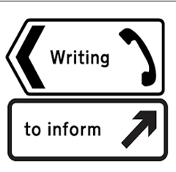 | 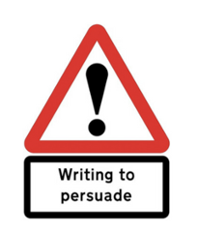 | 
Years 1/2
Years 3/4
Years 5/6

Objectives and Skills
At Turves Green, we have reduced the number of writing objectives each year group has to complete in a year to approximately 20. These should be taught and embedded throughout the year. Our aim is that 100% of pupils use these 100% accurately, 100% of the time by the end of the year. This is achieved through precise teaching, repeated practise of the skills and effective feedback.
Structure of the Week
The writing week is designed so that pupils can develop all aspects of their writing.
 | Monday | Tuesday |  | Wednesday |  | Thursday |  | Friday
Years 1/2 | Handwriting |  | Spelling | Spelling |  | VGP | Composition | VGP | Composition
Years 3/4 | Handwriting | Spelling |  | VGP | Composition | VGP | Composition | VGP | Composition
Years 5/6 | Handwriting | Spelling |  | VGP | Composition | VGP | Composition | VGP | Composition

Vocabulary, grammar and punctuation (VGP) and Composition Lessons
These lessons will be split so that 30 minutes of the lesson is dedicated to VGP and 30 minutes is dedicated to the teaching of sentence structure and composition.
The focus for the VGP element of the lessons come from the KPIs/ objectives for each year group.
Handwriting
Handwriting is taught using the Nelson scheme. Teachers should demonstrate consistently, high expectations for pupils handwriting. Teachers are expected to use this font in their written comments and pupils are expected to apply this across all their learning.
Spellings
To teach spelling we use the Spelling Shed online scheme. This contains 216 lessons. These are based on phonics (orthography), morphology and etymology and they include the main teaching inputs, which can be followed up with additional activities as required.

Yearly Overview Plan
KS2
