15th June 2022
Year 6 Leavers Activities
Dear Parents,
As we are fast approaching the end of the year, we wanted to share with you the dates of the exciting events we have planned for our Year 6’s! We will provide you with the full details in the upcoming weeks.

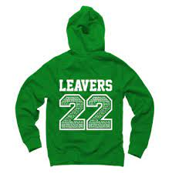
- Thursday 7th July at 1.30pm – Year 6 sale in the hall. All proceeds go towards the leavers party.
- Monday 18th July 4.15pm until 6pm – Leavers party in the hall.
- Tuesday 19th July at 1.30 pm – Leavers Assembly in the hall.
- When leavers hoodies arrive, these can be worn in place of school jumpers.
It is with a very heavy heart that we must say goodbye to our lovely Year 6’s however we look forward to recognising and celebrating the children’s time and hard work at Turves Green with you all!
Thank you,
Miss Beech and Miss Smith
Goodbye & Good Luck

