Pupil premium strategy statement – Turves Green Primary School
This statement details our school’s use of pupil premium (and recovery premium) funding to help improve the attainment of our disadvantaged pupils.
It outlines our pupil premium strategy, how we intend to spend the funding in this academic year and the outcomes for disadvantaged pupils last academic year.

School overview
Detail | Data
Number of pupils in school | 355
Proportion (%) of pupil premium eligible pupils | 64% (227 pupils out of  355)
Academic year/years that our current pupil premium strategy plan covers (3 year plans are recommended) | 2025 - 2028
Date this statement was published | 31st December 2025
Date on which it will be reviewed | 1st December 2026
Statement authorised by | Emma Young (Headteacher)
Pupil premium lead | Emma Young
Governor / Trustee lead | Naomi Jeavons  Danika Heath

Funding overview
Detail | Amount
Pupil premium funding allocation this academic year | £352,995
Recovery premium funding allocation this academic year | £0
Total budget for this academic year  If your school is an academy in a trust that pools this funding, state the amount available to your school this academic year | £352,995

Part A: Pupil premium strategy plan

Statement of intent
Ofsted has stated, “Leaders, including members of the trust, are highly ambitious for all pupils. They know the school and its community well.” When deciding on how best to support all children in our school, it is important to consider the children, families and their backgrounds and the community we serve. We must identify the challenges that can arise for our children: 64% of which are entitled to pupil premium funding.
We use research from the Education Endowment Foundation to identify areas for development to improve outcomes and opportunities for our disadvantaged children to achieve at least the age-related expectation in all areas of the curriculum. We want our disadvantaged children to make better than expected progress to close the gap between disadvantaged and non-disadvantaged children. We want our children to have the best start to their education so that they are ready to start secondary school.
We also consider the challenges faced by vulnerable children, such as those who have a social worker assigned to them, and those with SEND. The activity we have outlined in this statement is also intended to support their needs, regardless of whether they are eligible for the pupil premium funding or not.
High quality teaching is at the heart of our approach, with a focus on the areas in which disadvantaged children require the most support. This is proven to have the greatest impact on closing the disadvantage attainment gap and will at the same time benefit the non-disadvantaged children in the school. Implicit in the intended outcomes detailed below is the intention that non-disadvantaged children’s attainment will be sustained and improved alongside progress for their disadvantaged peers. Our strategy is also integral to wider school plans for education recovery, notably in its targeted support for children whose education has been worst affected including non-disadvantaged children. Our approach will be responsive to common challenges and individual needs, rooted in robust diagnostic assessment, not assumptions about the impact of disadvantage. The approaches we have adopted complement each other to help children excel.

Demography and School Context
Turves Green Primary School is an average-sized school. We have 355 pupils on roll
(December 2025). It is on the same road as Turves Green Boys’ School, King Edwards Northfield School for Girls and Albert Bradbeer Primary School. The proportion of pupils who are known to be eligible for support through the pupil premium (December 2025 – 64%) is almost three times the national average (23.8% - 2022 – 2023).

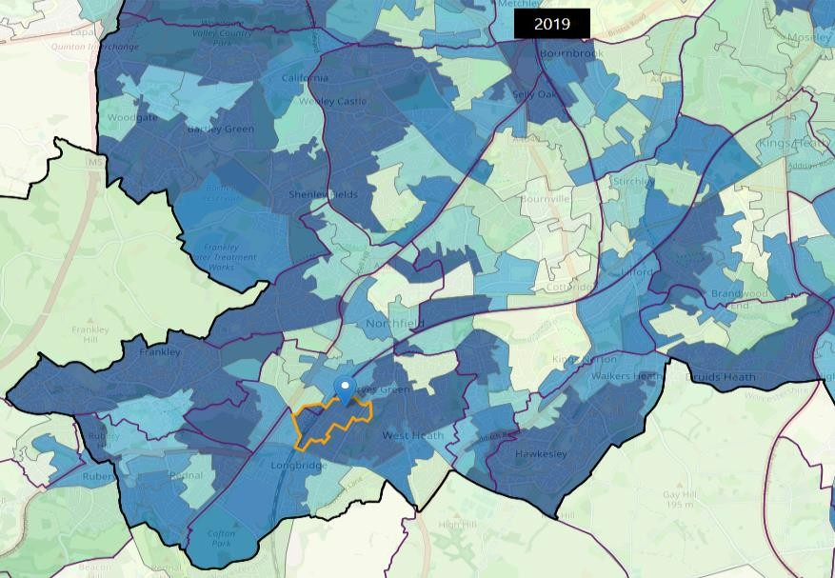
When providing Early Help, links to many other agencies can be made to provide families with additional support. One example of this is Dream Team, who help to reduce bed poverty. We direct families to Rubery Community Swop Shop for school uniform and we also collect for our local food bank, The Trussell Trust.
A lot of Turves Green pupils live close to the school with many living in flats. The map illustrates areas of high deprivation close to school.
In 2019, the indices of deprivation showed that
Turves Green Primary School is located amongst the 10% most deprived neighbourhoods in the country.
Data Source: Indices of Deprivation
2015 and 2019
(communities.gov.uk)

Our Key Objective
To narrow the attainment gap between disadvantaged pupils and all pupils both within internal school data and nationally.
Our objectives:
- We will adopt a whole school approach in which all staff take responsibility for disadvantaged children’s outcomes and raise expectations and aspirations.
- We will ensure high-quality teaching and learning is supported through robust research-based approaches in developing both staff and children.
- We will ensure disadvantaged children are challenged in the learning they are set, and that appropriate scaffolding is used as appropriate.
- We will ensure wide and rich experiences are available for all disadvantaged children.
We also recognise that not all children who are socially disadvantaged are registered or qualify for free school meals. We reserve the right to allocate the Pupil Premium funding to support any child or group of children the school legitimately identifies as being socially disadvantaged.

Challenges
This details the key challenges to achievement that we have identified among our disadvantaged pupils.
Challenge number | Detail of challenge
1 | Low attainment on entry to reception, particularly with language and communication skills. Many children enter reception below age-related expectations.
2 | Low cultural capital of pupils.
3 | School attendance and punctuality.
4 | Minimal parental engagement.
5 | Chaotic family environment and involvement of external agencies leading to a lack of emotional resilience and ability to self-regulate, leading to higher rates of fixed term suspension.
6 | Impact of COVID-19 Pandemic

Intended outcomes
This explains the outcomes we are aiming for by the end of our current strategy plan, and how we will measure whether they have been achieved.
Intended outcome | Success criteria
For disadvantaged pupils to achieve at  least national average reading levels by  the end of Year 6. | Consistently achieve at least national  average score in KS2 reading by 2027
For disadvantaged pupils to achieve at  least national average writing levels by  the end of Year 6. | Consistently achieve at least national  average score in KS2 writing by 2027
For disadvantaged pupils to achieve at  least national average maths levels by  the end of Year 6. | Consistently achieve at least national  average score in KS2 maths by 2027
For disadvantaged pupils to exceed  national average attainment in Read,  Write Inc. (phonics) from their starting  points. | Consistently achieve national average  expected standard in PSC by 2027
Disadvantaged children’s school  attendance exceeds or is at least in line  with all children nationally (2024-25  Primary 94.8%) | Children achieve a minimum of 94.8%  attendance.  The percentage of all children who are persistently absent being below the national average and the gap between disadvantaged children and their peers reducing.
Disadvantaged children’s fixed term suspension levels decrease in line with disadvantaged school children nationally (2023-2024 – 0.99% of disadvantaged pupils) | Effective proactive strategies embedded to support children.  Levels of fixed term suspensions for disadvantaged children reduces.

Activity in this academic year
This details how we intend to spend our pupil premium (and recovery premium) funding this academic year to address the challenges listed above.

Teaching (for example, CPD, recruitment and retention)
Budgeted cost: £237,395
Activity | Evidence that supports this approach | Challenge number(s) addressed
Excellent quality first teaching (QFT) in all year groups. Key priority as all children achieve best through effective class teaching, link to school development plan.  Improve subject knowledge through coaching and mentoring:  Coaching from MAT Director of English and MAT Director of Maths Leads used as appropriate  Improve the subject knowledge of ECTs within ORACY using DLE attendee’s focus project.  Develop and implement an effective marking policy.  Enrolment of member of staff on 3 day Maths No Problem Essentials course. | “The best available evidence indicates that great teaching is the most important lever schools have to improve pupil attainment. Ensuring every teacher is supported in delivering high-quality teaching is essential to achieving the best outcomes for all pupils, particularly the most disadvantaged among them.”  - High-quality teaching | EEF  Diagnostic_Assessment_Tool.pdf | 1, 2, 3, 6
Use teaching assistants to enhance the academic provision in school by supporting learners in class |  | 1,6
Use of pupil progress meetings to track progress of disadvantaged children, Use of assessment for learning and summative assessment date to ensure gap are closing |  | 1, 6
Development of an engaging, inclusive curriculum for children to enjoy and access. Support from MAT Curriculum Lead to upskill teachers’ subject knowledge and high-quality delivery. Clear links to English will enable improved opportunities for writing content. | If children enjoy school, they will want to attend. A curriculum designed to meet the needs and interests of children will engage learning. Inclusive approaches benefit all students, regardless of background, by making learning relevant and accessible, linking strongly to closing disadvantage gaps. | 1, 2, 3, 6
Use of CPL approach based on Walkthrus  Triad teams established  Teacher release time to support planning  Enrol all early career teacher into ECT 2 programme led by the  Arthur Terry Learning  Partnership | Evidence suggests that quality CPD has a greater effect on pupil attainment than other interventions schools may consider.  Evidence review: The effects of high-quality professional development on teachers and students - Education Policy Institute | 1, 2, 3, 6
Use of oracy to improve language and vocabulary for all to raise attainment in all subjects. Priority identified as many children arrive at school with lower than-average communication and language skills, many children disadvantaged through language poor backgrounds. Teacher enrolled on DLE with this as project focus. ORACY Lead release to complete project  Focus in EYFS and KS1 on language development for all – Wellcomm and RWI (Strong Start to Reception) MAT funded RWI training. Teacher cover  Oracy (Voice 21)  Spelling Shed / mathletics / TTRS |  | 1, 2, 6
Embed enhanced provision and participation in physical education led by specialist sports coach delivering lessons, after school clubs and inter-school competitions.  Sports Coach cost  Young Voices / Choir ran by teacher, opportunity to perform at Utilitia Arena. Cover cost for concert day | Provide enhanced opportunities and experiences for pupils. “The average impact of the engaging in physical activity interventions and approaches is about an additional one month’s progress over the course of a year… There are wider benefits from regular physical activity in terms of physical development, health and wellbeing as well as other potential benefits have been reported such as improved attendance… Pupils from disadvantaged backgrounds may be less likely to be able to benefit from sport clubs and other physical activities outside of school due to the associated financial costs (e.g. equipment). By providing physical activities free of 4, 6 8 charge, schools give pupils access to benefits and opportunities that might not otherwise be available to them.”  Research reveals a positive correlation between participation in enrichment activities and increased school attendance.  New research reveals positive link between enrichment and tackling the school attendance crisis | Centre for Young Lives | Press Release | 2, 3, 5, 6
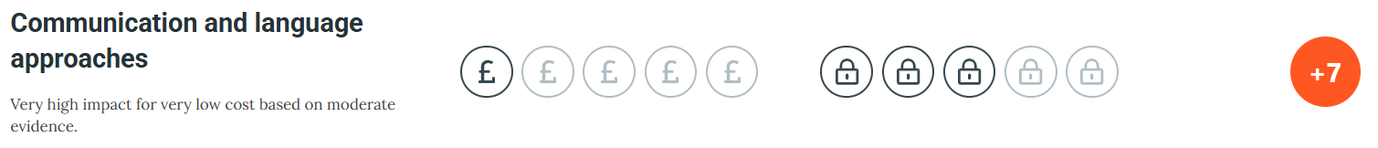
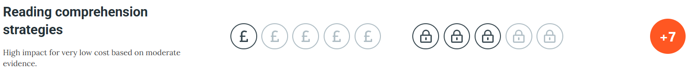
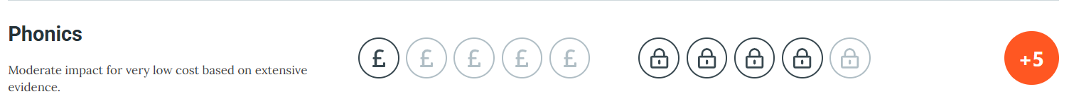
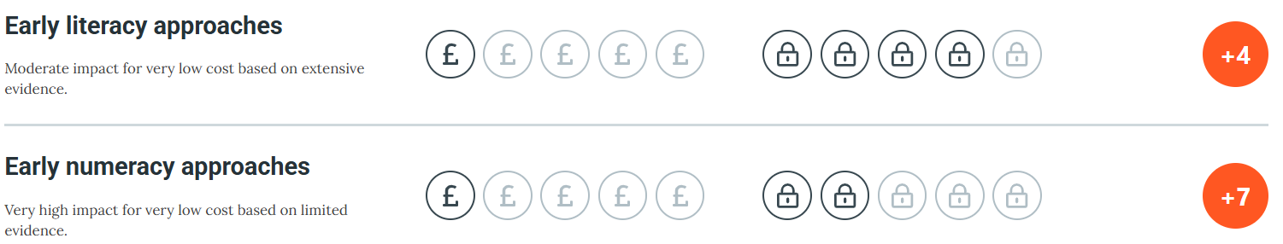

Targeted academic support (for example, tutoring, one-to-one support, structured interventions)
To raise attainment in Key Stage 2 in all subjects for all pupils eligible for the Pupil Premium Grant so that it is in line with national figures.

Budgeted cost: £69,000
Activity | Evidence that supports this approach | Challenge number(s) addressed
Use teaching assistants to enhance the academic provision in school by supporting learners providing small group support, including catch-up.  Smaller teaching groups in Year 6 to enable increased focus of teaching.  Wellcomm assessments and interventions to take place in EYFS and Y1 as appropriate. Training for TAs and purchase of Wellcomm  Small group phonic intervention as needed.  TA training  RWI Portal access | Gaps in attainment between disadvantaged and all pupils in school identify the need for focused and timely interventions in class, providing additional capability for pupils to receive small group support and catch-up.  Teaching targeted at specific needs and knowledge gaps can be an effective method to support low attaining children or those falling behind, both one to one and in small groups.  EEF statement on closing the disadvantage gap using Oneto-One Tuition and Small Group Tuition: Studies in England have shown that pupils eligible for free school meals typically receive additional benefits from one-to-one tuition and small group tuition. Low attaining pupils are particularly likely to benefit. | 1, 3, 5, 6
Purchase of CGP books for Year 6 pupils  Subscription to Testbase | CGP books ensures purposeful homework is given to pupils, they meet the National Curriculum objectives and offers a scaffold / support that will enable pupils to successfully complete their SATs. Testbase allows for the easy creation of homework activities based on areas of need. | 1, 3, 4, 5, 6

Wider strategies (for example, related to attendance, behaviour, wellbeing)
Budgeted cost: £46,600
Activity | Evidence that supports this approach | Challenge number(s) addressed
Pastoral manager to support families with access to outside agencies  Pastoral Manager to continue work with families with poor attendance offering support as appropriate | The DfE guidance to reduce levels of absence and persistent absence has been used to inform our support for families who struggle with school attendance, alongside Birmingham’s Support First document. | 3, 4, 5, 6
Regular invitations to school assemblies, workshops, coffee mornings. To improve parental engagement with school initiatives. | “Parental engagement has a positive impact on average of 4 months’ additional progress. It is crucial to consider how to engage with all parents to avoid widening attainment gaps.” EEF | 3, 4
Use of pastoral team to support children with acute SEMH needs including one to one and small group interventions (including for metacognition and self-regultion strategies) by learning mentors | “The average impact of metacognition and self-regulation strategies is an additional eight months’ progress over the course of a year.” EEF | 1, 3, 4, 5, 6
Raise the profile of good attendance and punctuality Monthly attendance prize |  | 3, 4
Further develop staff knowledge and confidence to manage challenging behaviours, including training and support to create a whole school understanding of and strategy for disadvantaged pupils. Reduce Fixed Term Suspensions, particularly for disadvantaged pupils.  TIASS training with Birmingham EP service. |  | 3, 4, 5, 6
Increased opportunities to engage with wider learning experiences – visits, visitors – to raise aspirations and provide life experiences. At least one subsidised trip or visitor planned for each year group to include a range of activities to cover full curriculum and additional wider experiences. |  | 2, 3
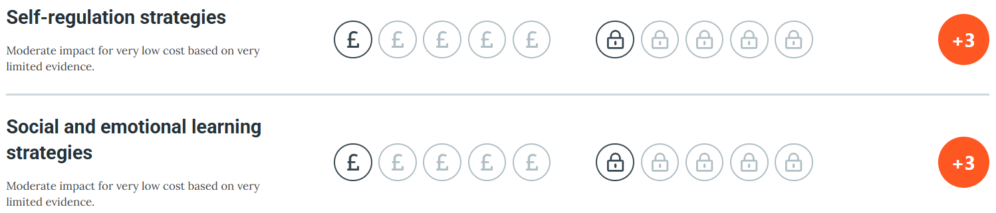

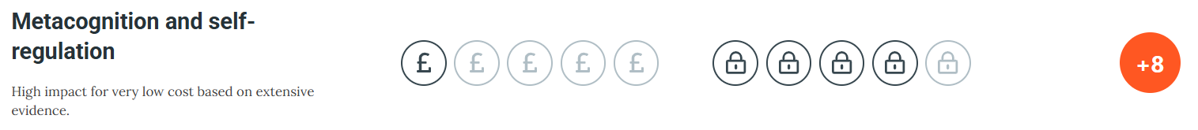

Total budgeted cost: £352,995

Part B: Review of the previous academic year

Outcomes for disadvantaged pupils
During the academic year 2024-2025, disadvantaged pupils achieved below their peers in maths, which in turn created a gap in reading, writing and maths combined.

Whole School Data
 | Key Stage 2
 | Expected + | Greater Depth
Reading | 65% | 23%
Writing | 62% | 0%
Maths | 62% | 23%
Combined Reading, Writing, Maths | 59% | 0%
GPAS | 55% | 27%

Pupil Premium Data
 | Key Stage 2
 | Expected + | Greater Depth
Reading | 53% | 13%
Writing | 50% | 0%
Maths | 50% | 13%
Combined Reading, Writing, Maths | 45% | 0%
GPAS | 42% | 16%

Externally provided programmes
Please include the names of any non-DfE programmes that you used your pupil premium to fund in the previous academic year.
Programme | Provider
Wellcomm | GL Assessment
TT Rockstars | TT Rockstars
Mathletics | 3P Learning

Service pupil premium funding (optional)
For schools that receive this funding, you may wish to provide the following information: How our service pupil premium allocation was spent last academic year
N/A
The impact of that spending on service pupil premium eligible pupils
N/A

