Turves Green Primary School Curriculum 2020-2021

INTENT
Our school curriculum reflects our school aims and values and takes account of the National Curriculum (2014). The intent of our curriculum is to ensure that our pupils are equipped with life skills they may not have had the gain elsewhere. The sequence of teaching supports age-appropriate development at each phase.

Curriculum Model
The principles of breadth, balance and diversity underpin the three agreed curriculum Intents which form the cornerstones of our school curriculum. The three curriculum Intents are: i) personal development; ii) the development of key skills; iii) opportunity to broaden knowledge and experiences.
The personal development Intent incorporates aspects of self-awareness, shared values, and understanding of equality, diversity and inclusion, and is covered through timetabled PHSME; R.E.; P.E.; and EQ lessons.
The key skills Intent aims to ensure high levels of individual attainment and progress in the core subjects of English, Maths and Science.
The broadening experiences intent is covered through cross curricular topics which include History, Geography, Art, D.T., MFL and Music. This is further enhanced by an extended curriculum which includes focus days and events, visiting speakers, Forest School visits, and a residential experience.
ICT/Computing is taught through, and supports, all of the curriculum subjects where possible, and follows a defined progression of skills.

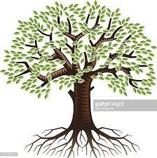

BROADENING

EXPERIENCES:

Curriculum Topics

History/ Geography/ Art/ D.T./ Music/ MFL

Extended curriculum experiences

KEY SKILLS:

English/

Maths/
Science/ ICT

PERSONAL & SOCIAL DEVELOPMENT: Self
-
awareness/
Emotional Literacy/ Awareness & understanding of

Equality,

Inclusion and Diversity/ PHSME/R.E./P.E.

IMPLEMENTATION

Curriculum Framework
The curriculum framework shows how subjects are covered throughout an academic year. It is a framework based on some subjects being continuously taught, e.g Maths; some subjects discretely taught as blocks, e.g Science, and other subjects taught as part of linked cross-curricular topics, e.g History.
The curriculum framework changes each academic year to reflect the length of the three terms.
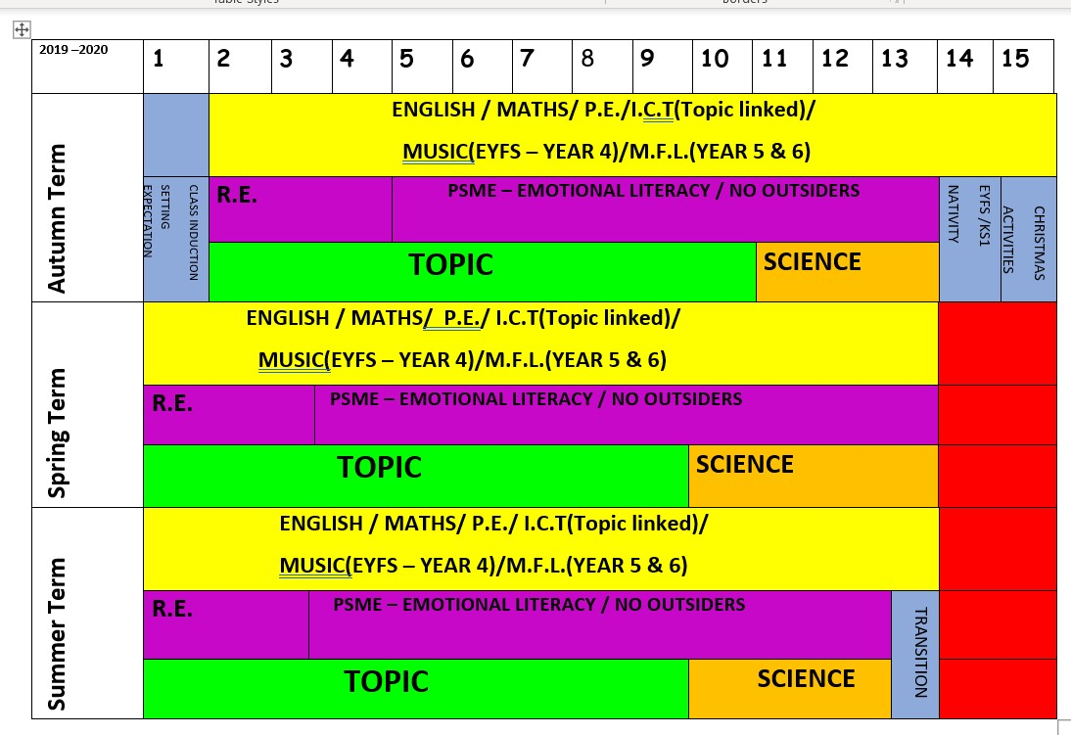

Whole School
Curriculum Overview

The curriculum overview shows curriculum coverage for the whole
school
, indicating for each year group the cross
curricular themes , Science units and R.E to be covered each term.

TURVES GREEN PRIMARY SCHOOL CURRICULUM OVERVIEW
 | AUTUMN TERM |  |  | SPRING TERM |  |  | SUMMER TERM
 | TOPIC | SCIENCE | R.E | TOPIC | SCIENCE | R.E | TOPIC | SCIENCE | R.E
YEAR 1 | HEROES AND  VILLAINS | MATERIALS AND  THEIR  PROPERTIES  SEASONAL CHANGES | BIBLE STORIES OF JESUS  CHRISTMAS & THE NATIVITY | THROUGH  THE  WINDOW  (Local area study) | LIFE & LIVING PROCESSES  ANIMALS | CHRISTIANITY  - EASTER | THE GREAT  POST OFFICE  MYSTERY | PLANTS | SPECIAL BOOKS  – THE TORAH &  THE Q’URAN
YEAR 2 | THE GREAT  FIRE OF  LONDON | MATERIALS – PROPERTIES &  CHANGING  MATERIALS | HINDUISM – BASIC BELIEFS  DIWALI | AHOY THERE!  EXPLORERS | LIVING THINGS & THEIR  HABITATS/LIFE  PROCESSES | CHRISTIANITY  – TEACHINGS  OF JESUS | SEASIDE  RESORTS | PLANT  GROWTH | ISLAM – EID  CELEBRATIONS
YEAR 3 | THE  WONDERFUL  WORLD OF  WILLY  WONKA | LIGHT  ROCKS | JUDAISM-BASIC  BELIEFS | TRANS  SIBERIAN RAILWAY JOURNEY | FORCES AND MAGNETS | ISLAM – THE 5  PILLARS  RITES OF  PASSAGE | ANCIENT  EGYPT | PLANTS  ANIMALS &  HUMANS | CHRISTIANITY-  WHAT IS A CHURCH?  (VISIT)
YEAR 4 | KINGS AND  CASTLES –  THE  NORMANS | SOUND  ELECTRICITY | SIKHISM – BASIC BELIEFS  GUDWARA  (VISIT) | AWESOME  OCEANS | CLASSIFICATION  FOOD CHAINS  DIGESTION  TEETH | JUDAISM –  KEY FESTIVALS | EXTREME  EARTH | CHANGING  MATERIALS | CHRISTIANITY  – WHO WAS JESUS?
YEAR 5 | THE ROMANS  ARE  COMING! | MATERIALS – REVERSIBLE &  NON-  REVERSIBLE CH. | ISLAM –  MUHAMMED  AND THE  MOSQUE(VISIT) | AMAZONIAN  ADVENTURE | LIFE CYCLES  REPRODUCTION | CHRISTIANITY  - STORIES  FROM THE  BIBLE | SPACE – THE  FINAL  FRONTIER | EARTH AND  SPACE | BUDDHISM –  BASIC BELIEFS
YEAR 6 | WORLD WAR  2 | CLASSIFICATION  PLANTS AND  ANIMALS | CHRISTIANITY –  BELIEF IN OUR  COMMUNITY | CIVIL RIGHTS | EVOLUTION &  ADAPTATION  HUMAN BODY  & HEALTH | HINDUISM – BELIEFS AND  THE MANDIR | SPIES – MISSION  IMPOSSIBLE | LIGHT  ELECTRICITY | JUDAISM –  WORSHIP AND  THE  COMMUNITY

Topic Curriculum Overviews
Each Year group covers three cross curricular termly topics, which have either a history, geography or Literacy focus. Termly topic overviews record the main NC objectives to be covered, links with Literacy and Maths as well as the main resources to be used.
Science topics are taught in blocks so that the NC objectives for each year group are covered across the year. At least one full investigation is completed each term. In each lesson there is also a focus on developing the use of subject specific vocabulary or the teaching of an investigative science skill.
Art and DT have been broken down into different key areas of knowledge. For Art, this is: drawing, painting, printing, textiles and 3D form. Art activities linked to curriculum themes have then been planned so that there is broad, even coverage of each knowledge area across each key stage. For DT, this is: Electrical systems, mechanical systems, Cooking and nutrition and textile Projects. These have been planned on a cyclical structure, so each area is covered, once in KS1 and twice in KS2. At least one full project is completed each year, covering the Design, Make, evaluate structure, while other skills are taught discreetly as mini activities and projects.
Computing is taught as discrete half termly units. These have been linked to topics where appropriate. Each Year group also completes a Young Engineers whole day activity programme, using computer programmes to design, control and test models.
Music is taught using the Charanga music programme. Three termly units are taught either as a half termly block or alternate weeks across the term.
MFL is taught in Years 5 and 6. Lessons are taught as half termly blocks or alternate weeks across the term. Links are made with specific topics where appropriate (Eg Spies in Year 6)
PSHE and RE are taught across each term.
PE is taught in half termly units to ensure a range of skills and activities are taught across each key stage.
(For the teaching of Reading, Writing and Maths, see the appropriate subject policy).

Subject Progression Maps
These maps provide a guide for the skills and knowledge which need to be taught in each year group. These documents are then used as part of monitoring to ensure that children are working at the appropriate level and covering all the skills and knowledge expected.
As a result of professional development meetings, Staff understand the development of skills through basic to developing, to mastery, and plan activities accordingly, to ensure that all skills are covered, and children are challenged in their learning.

Lessons
A weekly planning proforma is completed for each topic. This shows the progression of the topic and the build-up of knowledge and skills. It identifies the learning objective for the lesson and the activities to be completed. Any differentiated activities to support or extend learning are recorded along with any links to rights respecting and British Values. A wide variety of both recorded and practical activities are planned to engage and enthuse the children and provide the opportunity access to all areas of the curriculum.

Broadening knowledge and experiences
This is developed through taking part in both written and practical activities, visits, visitors, and competitions with other schools. Specific focus weeks are timetabled into the school year.
Examples Include:
- In each year group, children complete visits to a religious place of worship
- In each year group, children complete at least one visit linked to their topic which extends and contextualises their learning.
- There is a wide range of extra-curricular P.E clubs skipping, netball, rounders, and football as well as the opportunity to compete in inter school competitions including football, cricket, netball, gymnastics, athletics and dance.
- Science Week, including specific assemblies, competitions and visits to the Big Bang Science event promote interest and enthusiasm in the subject.
- Art week is used to further promote knowledge of different artists and their work. Work.

IMPACT
Books, displays, topic booklets and website entries provide evidence of the broad range of phase appropriate skills and knowledge being covered with age-appropriate subject specific vocabulary being used accurately and consistently. They also demonstrate the links made in their learning across the curriculum.
Pupil Voice demonstrates a huge improvement in the children’s attitude to their learning.

Personal Development
- Children demonstrate a clear, confident knowledge of equality and issues which affect children across the world.
- Silver Rights Respecting achieved
- Data analysis shows a significant drop in incidences of low disruption.
- Data analysis shows a consistent drop in homophobic and racial incidents.

