Pupil premium strategy statement – Turves Green Primary School
This statement details our school’s use of pupil premium (and recovery premium) funding to help improve the attainment of our disadvantaged pupils.
It outlines our pupil premium strategy, how we intend to spend the funding in this academic year and the outcomes for disadvantaged pupils last academic year.

School overview
Detail | Data
Number of pupils in school | 386
Proportion (%) of pupil premium eligible pupils | 62% 239/386
Academic year/years that our current pupil premium strategy plan covers (3 year plans are recommended) | 2022 – 2023 to 2024-2025
Date this statement was published | 31st December 2023
Date on which it will be reviewed | 1st December 2024
Statement authorised by | Debbie Holland
Pupil premium lead | Leanne Foster-Clee
Governor / Trustee lead | Hayley Wadley

Funding overview
Detail | Amount
Pupil premium funding allocation this academic year | £329,558
Recovery premium funding allocation this academic year | £0
Pupil premium (and recovery premium*) funding carried forward from previous years (enter £0 if not applicable)  *Recovery premium received in academic year 2021 to 2022 can be carried forward to academic year 2022 to 2023. Recovery premium received in academic year 2022 to 2023 cannot be carried forward to 2023 to 2024. | £0
Total budget for this academic year  If your school is an academy in a trust that pools this funding, state the amount available to your school this academic year | £329,558

Part A: Pupil premium strategy plan

Statement of intent
Ofsted has stated, “At Turves Green Primary School, everyone is valued and included.” When deciding on how best to support all children in our school, it is important to consider the children, families and their backgrounds and the community we serve. This means identifying the challenges that can arise for our children.
We use research from the Education Endowment Foundation to identify areas for development to improve outcomes and opportunities for our disadvantaged children to achieve at least the age-related expectation in all areas of the curriculum. We want our disadvantaged children to make better than expected progress to close the gap between disadvantaged and non-disadvantaged children. We want our children to have the best start to their education so that they are ready to start secondary school.
We also consider the challenges faced by vulnerable children, such as those who have a social worker assigned to them, and those with SEND. The activity we have outlined in this statement is also intended to support their needs, regardless of whether they are eligible for the pupil premium funding or not.
High quality teaching is at the heart of our approach, with a focus on the areas in which disadvantaged children require the most support. This is proven to have the greatest impact on closing the disadvantage attainment gap and will at the same time benefit the non-disadvantaged children in the school. Implicit in the intended outcomes detailed below is the intention that non-disadvantaged children’s attainment will be sustained and improved alongside progress for their disadvantaged peers. Our strategy is also integral to wider school plans for education recovery, notably in its targeted support for children whose education has been worst affected, including non-disadvantaged children. Our approach will be responsive to common challenges and individual needs, rooted in robust diagnostic assessment, not assumptions about the impact of disadvantage. The approaches we have adopted complement each other to help children excel.
Demography and School Context
Turves Green Primary School is an average-sized school. We have 383 pupils on roll (November 2023). It is on the same road as Turves Green Boys’ School, King Edwards Northfield School for Girls and Albert Bradbeer Primary School. The proportion of pupils who are known to be eligible for support through the pupil premium (November 2023 - 64%) is almost three times the national average (23.8% - 2022 – 2023).
Our school supports our local community working in conjunction with King Edward VI Northfield School for Girls and Turves Green Boys’ School. When providing Early Help, links to many other agencies can be made to provide families with additional support. One example of this is Dream Team, who help to reduce bed poverty. We hold school events such as Swap Shop for clothes and we also collect for our local food bank, The Trussell Trust.
A lot of Turves Green pupils live close to the school with many living in flats close to the school. The map illustrates areas of high deprivation close to school.
In 2019, the indices of deprivation showed that Turves Green Primary School is located amongst the 10% most deprived neighbourhoods in the country.
Data Source: Indices of Deprivation 2015 and 2019 (communities.gov.uk)

Our Key Objective
To narrow the attainment gap between disadvantaged pupils and all pupils both within internal school data and nationally.
Our objectives:
- We will adopt a whole school approach in which all staff take responsibility for disadvantaged children’s outcomes and raise expectations and aspirations.
- We will ensure high-quality teaching and learning is supported through robust research-based approaches in developing both staff and children.
- We will ensure disadvantaged children are challenged in the learning they are set.
- We will ensure wider experiences are available for all disadvantaged children.
- We also recognise that not all children who are socially disadvantaged are registered or qualify for free school meals. We reserve the right to allocate the Pupil Premium funding to support any child or group of children the school legitimately identifies as being socially disadvantaged.

Challenges
This details the key challenges to achievement that we have identified among our disadvantaged pupils.
Challenge number | Detail of challenge
1 | Many children enter Reception below age related expectations for their age.
2 | Poor language and communication skills with gaps in vocabulary knowledge.
3 | Poor metacognitive and self-regulation skills.
4 | Low cultural capital of pupils.
5 | School attendance and punctuality.
6 | Minimal parental engagement.
7 | Need for involvement of external agencies for many families.

Intended outcomes
This explains the outcomes we are aiming for by the end of our current strategy plan, and how we will measure whether they have been achieved.
Intended outcome | Success criteria
Improved oral language skills and vocabulary acquisition among disadvantaged children to impact positively on attainment. | Assessments and observations indicate improved oral language among disadvantaged children. Achieve at least national average score in KS2 for reading and writing.
Improved phonics attainment among disadvantaged children. | The phonics check will show national average scores.
Improved attainment at the end of year 6 in reading, writing and maths, particularly for disadvantaged children. | End of KS2 results show more disadvantaged children achieve age-related expectations in reading, writing and maths.
To achieve and sustain improved wellbeing for all children in our school, particularly among disadvantaged children. | Sustain high levels of wellbeing from 2023 - 24 demonstrated by:  • Qualitative data from child and parent surveys and teacher observations.
To achieve and sustain improved attendance for all children, particularly our disadvantaged children. | • The overall absence rate for all children being no more than the national average, and the attendance gap between disadvantaged children and non-disadvantaged children is reduced from the 2022 - 2023 figure.  • The percentage of all children who are persistently absent being below the national average and the gap between disadvantaged children and their peers reducing.

Activity in this academic year
This details how we intend to spend our pupil premium (and recovery premium) funding this academic year to address the challenges listed above.

Teaching (for example, CPD, recruitment and retention)
Budgeted cost: £77,810
Activity | Evidence that supports this approach | Challenge number(s) addressed
Excellent teaching in all year groups  Priority as all children achieve best through effective class teaching, link to school development plan.  • Use of CPL approach based on Walkthrus  £2000  • Use of Iris to support teacher self and coach evaluation  £4,600  • Leadership release time to support planning and paired teaching  £30,000  • Cover for supported observations  £15,000  • Coaching used as appropriate  £10,000  • Improve subject knowledge  • Planning clinics  • Enrol all early career teacher into ECT programme led by the Arthur Terry Learning Partnership  £3,000  • Improve children’s metacognition to develop resilience and independence using Let’s Think in English £2,600  Oracy (Voice 21)  £110  Spelling Shed and Literacy resources  £1,000 | There is strong evidence that supporting high quality teaching is pivotal in improving children’s outcomes. Research tells us that high quality teaching can narrow the disadvantage gap. It also says that promoting effective professional development improves classroom practice and pupil outcomes.  EEF statement on closing the disadvantage gap using metacognition: There is some evidence to suggest that disadvantaged pupils are less likely to use metacognitive and self-regulatory strategies without being explicitly taught these strategies. Explicit teaching of metacognitive and self-regulatory strategies could therefore encourage such pupils to practise and use these skills more frequently in the future. With explicit teaching and feedback, pupils are more likely to use these strategies independently and habitually, enabling them to manage their own learning and overcome challenges themselves in the future. | 1, 2, 3, 4,
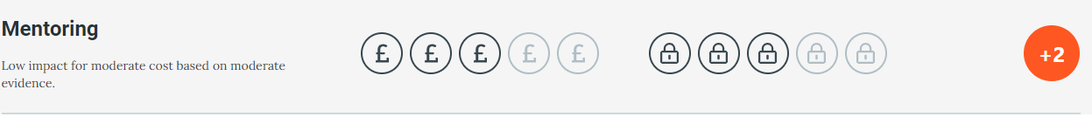
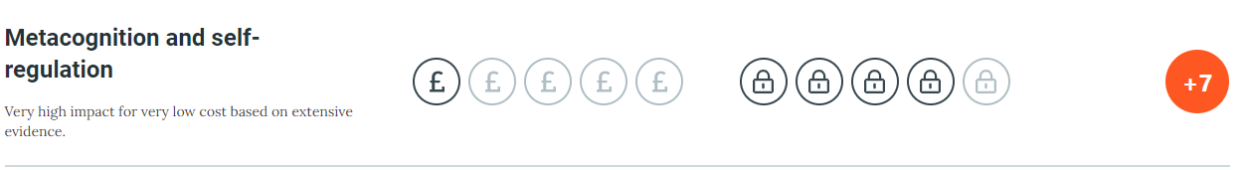
• Use of oracy to improve language and vocabulary for all to raise attainment in all subjects Priority identified as many children arrive at school with lower-than-average communication and language skills, many children disadvantaged through language poor backgrounds.  • Focus in EYFS to on language development for all  • Oracy taught throughout the school to improve children’s communication skills  Subscription to:-  -Wellcomm  £5,000 (and delivery)  -Read, Write, Inc books and resources and online portal  £4,500  -Voice 21 (already listed above) | There is strong evidence that suggests that oral language interventions, including activities such as high-quality classroom discussion, are inexpensive to implement and have a high impact on attainment.  EEF statement on closing the disadvantage gap using Oral Language Interventions: There is evidence to suggest that pupils from lower socioeconomic backgrounds are more likely to be behind their more advantaged counterparts in developing early language and speech skills, which may affect their school experience and learning later in their school lives.  Given that Oral Language Interventions can be used to provide additional support to pupils who are behind their peers in oral language development, the targeted use of approaches may support some disadvantaged pupils to catch up with peers, particularly when this is provided one-to-one. | 1,2
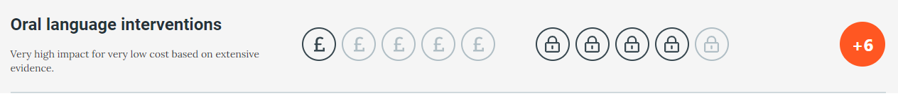
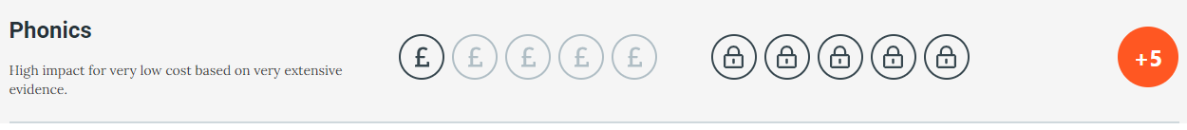

Targeted academic support (for example, tutoring, one-to-one support, structured interventions)
To raise attainment in Key Stage 2 in all subjects for all pupils eligible for the Pupil Premium Grant so that it is in line with national figures.

Budgeted cost: £117,000
Activity | Evidence that supports this approach | Challenge number(s) addressed
• Read Write Inc groups to be continued throughout lower key stage 2. Training for TAs to deliver RWI sessions.  Purchase of book bag books. Purchase of books to enhance provision.  • Smaller teaching groups in Year 1 and Year 6 to enable increased focus of teaching.  (Percentage of AHT salary x2)  • Interventions delivered by DHTs  (Percentage of DHT salary x2)  • Small group interventions and booster classes across school  £45,000  • Use of pupil progress meetings to track progress of disadvantaged children  • Use of assessment for learning and summative assessment date to ensure gap are closing | Teaching targeted at specific needs and knowledge gaps can be an effective method to support low attaining children or those falling behind, both one to one and in small groups.  EEF statement on closing the disadvantage gap using One-to-One Tuition and Small Group Tuition: Studies in England have shown that pupils eligible for free school meals typically receive additional benefits from one-to-one tuition. Low attaining pupils are particularly likely to benefit.  Studies in England have shown that pupils eligible for free school meals typically receive additional benefits from small group tuition. | 1, 2
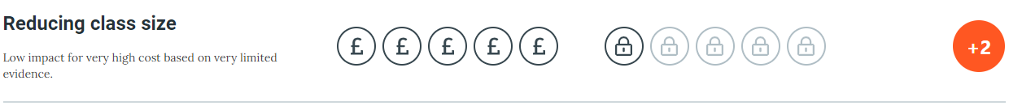
• Wellcomm assessments and interventions to take place in EYFS and Y1 as appropriate. Training for TAs and purchase of Wellcomm  • Small group phonic intervention as needed.  TA training  RWI Portal access  • Year 3 specific reading intervention delivered by class teachers  £5000 | There is strong evidence that suggests that oral language and synthetic phonic interventions, including activities such as high-quality classroom discussion, are inexpensive to implement and have a high impact on attainment.  EEF statement on closing the disadvantage gap using Phonics: Studies in England have shown that pupils eligible for free school meals typically receive similar or slightly greater benefit from phonics interventions and approaches. This is likely to be due to the explicit nature of the instruction and the intensive support provided. | 1, 2
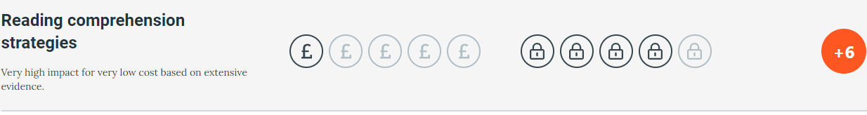
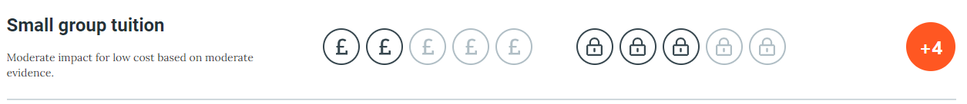

Wider strategies (for example, related to attendance, behaviour, wellbeing)
Budgeted cost: £134,748
Activity | Evidence that supports this approach | Challenge number(s) addressed
• Pastoral manager to support families with access to outside agencies  (Percentage of Pastoral Manager’s salary)  • Pastoral Manager to continue work with families with poor attendance offering support as appropriate  (Percentage of Pastoral Manager’s salary)  • To improve parental engagement with school initiatives  • Regular invitations to school assemblies, workshops, coffee mornings  • Use of pastoral team to support children with acute SEMH needs including one to one and small group interventions by learning mentors  (Percentage of Learning Mentor Salary x2)  • Training and support to create a whole school strategy for disadvantaged pupils  £400 | There is extensive evidence associating childhood social and emotional skills with improved outcomes in school and later in life  EEF social and emotional learning pdf.  The DfE guidance to reduce levels of absence and persistent absence has been used to inform our support for families who struggle with school attendance. | 5, 6, 7
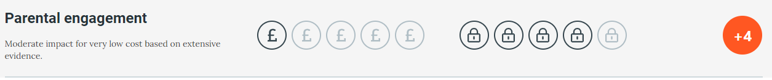
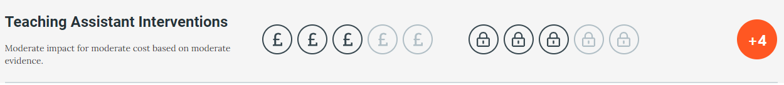
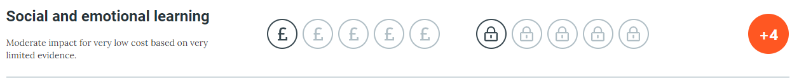
Increased opportunities to engage with wider learning experiences – visits, visitors – to raise aspirations and provide life experiences  • At least one subsidised trip or visitor planned for each year group.  £1,400  • Programme to include a range of activities to cover full curriculum and additional wider experiences.  • Purchase ‘Now Press Play’  £2,700  • Purchase OPAL to increase engaging activities to support metacognition and self-regulation.  £10,000 | There is evidence to suggest that children learn best when there is a mix of experiential learning paired with theoretical learning. Disadvantaged children have less access to a variety of life experiences to build on. | 1, 2, 3, 4,
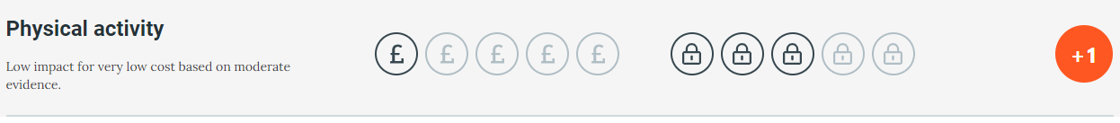
Contingency fund for acute issues  £45,248 | Based on our experiences we have identified a need to set aside a small amount of funding to respond quickly to needs that have not yet been identified. | 1, 2, 3, 4, 5, 6, 7

Total budgeted cost: £329,558

Part B: Review of the previous academic year

Outcomes for disadvantaged pupils
During the academic year 2022-2023, teacher assessments and standardised tests show that as disadvantaged children are progressing through the key stages, the disadvantage gap is closing, especially in reading and grammar, punctuation and spelling. Disadvantaged children are now achieving in maths at a higher rate than non-disadvantaged pupils, and collectively, the gap has closed for all children achieving the expected standard in combined reading, writing and maths at the end of Key Stage 2.

Whole School Data
 | Key Stage 1 |  |  | Key Stage 2
 | Expected + | Greater Depth |  | Expected + | Greater Depth
Reading | 45% | 6% |  | 56% | 19%
Writing | 39% | 0 |  | 58% | 11%
Maths | 49% | 10% |  | 59% | 6%
Combined Reading, Writing, Maths | 39% | 6% |  | 48% | 6%
GPAS | 45% | 6% |  | 58% | 21%

Pupil Premium Data
 | Key Stage 1 |  |  | Key Stage 2
 | Expected + | Greater Depth |  | Expected + | Greater Depth
Reading | 38% | 0 |  | 52% | 10%
Writing | 31% | 0 |  | 48% | 3%
Maths | 31% | 0 |  | 62% | 0
Combined Reading, Writing, Maths | 31% | 0 |  | 45% | 0
GPAS | 31% | 0 |  | 55% | 14%

Aim | Outcome
Improved oral language skills and vocabulary among disadvantaged children. | Percentage of child results  Red Amber Green  First assessment 58% 18% 25%  Last assessment 7% 21% 72%
Improved phonics attainment among disadvantaged children. | In 2023, children who took the Year 1 Phonics screening achieved the following:  85% of non-disadvantaged children  86% of disadvantaged children
Improved attainment at the end of year 6 in reading, writing and maths, particularly for disadvantaged children. | Reading – 72%  Writing – 75%  Maths – 77%  Combined Reading, Writing and Maths – 60%  Grammar, Punctuation and Spelling – 70%
To achieve and sustain improved wellbeing for all children in our school, particularly among disadvantaged children. | All children are using the Zones of Regulation and PD lessons to support their emotional wellbeing and regulation strategies. We took part in the Breathe Census to start to monitor wellbeing and take part in creating a Birmingham picture to help improve services.  A new Learning Mentor was employed with Counselling skills.  Mental Health Lead training completed.
To achieve and sustain improved attendance for all children, particularly our disadvantaged children. | The attendance figure for 2022-2023 was 93% which was an increase on the previous year’s figure of 92.46%

Externally provided programmes
Please include the names of any non-DfE programmes that you used your pupil premium (or recovery premium) to fund in the previous academic year.
Programme | Provider
Wellcomm | GL Assessment
TT Rockstars | TT Rockstars
Mathletics | 3P Learning

Service pupil premium funding (optional)
For schools that receive this funding, you may wish to provide the following information: How our service pupil premium allocation was spent last academic year
N/A
The impact of that spending on service pupil premium eligible pupils
N/A

Further information (optional)

