4th March 2022
Dear Everyone,
Comic Relief
Friday 18th March 2022 is Comic Relief Day. We are inviting children to come into school dressed as their favourite superhero, or in their own colourful clothing to raise money for Comic Relief. There is no suggested donation. Please just donate what you can.
This year Comic Relief are also giving children the opportunity to win £2,500 of LEGO for their school. Children are being asked to design a habitat (living space) for their favourite animal-themed red nose. They can create their designs using LEGO bricks, or paint or draw their design on paper. Entries will be judged on creativity, fun and understanding of animal habitats so feel free to let imaginations run wild!
Please bring all paper entries into school by Friday 18th March. For LEGO entries, please email a photo of the design to enquiry@turvesgreen.excelsiormat.org.
PE
We are asking that all children in Reception, Year 1 and Year 2 to bring their PE kit into school. This will be kept in school throughout each term and sent home at the end of each term for washing.
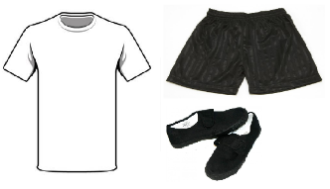
Children will come into school every day in their school uniform and change into their PE kit for their PE session.
Just a little reminder that our PE kit is a white T shirt, blue or black shorts, PE Skort or jogging bottoms and black pumps.
Turves Green Primary School Weekly Newsletter
Don’t forget our newsletter is now online only. This will be emailed as usual to all parents and carers registered for Arbor and also posted on our school website. To visit our school website, please scan the QR code provided at the bottom of this letter.

Have a great weekend,

Kerry Taylor
Office Manager

