Friday 30th April 2021
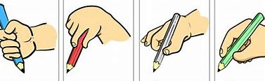
Dear Parents and Carers,
Virtual Parent Workshop: Developing Handwriting Skills

Date: Thursday 6th May 2021

Time: 1.30-2.30pm

Location: virtually via Microsoft TEAMS

Who this is for: Everyone! The session aims to support the development of handwriting skills for all ages and abilities.

Session highlights:
- Preparing to write
- Strategies to support pencil grip and hand discomfort
- Strategies to support handwriting development
- Suggested resources and links

Please complete the form below to register your interest and an invite will be sent via email. Please return the form by Wednesday 5th May.
Kind regards,

Laura Allden, AHT SENDCo

Please send me an email invite to the Virtual Handwriting Development Workshop on Thursday 6th May 2021 at 1.30pm.
Parent/ carer name (please print):_______________________________________________
Email address:______________________________________________________________
Child’s name:____________________ Child’s class:_____________________

